* IMPROVEMENT –

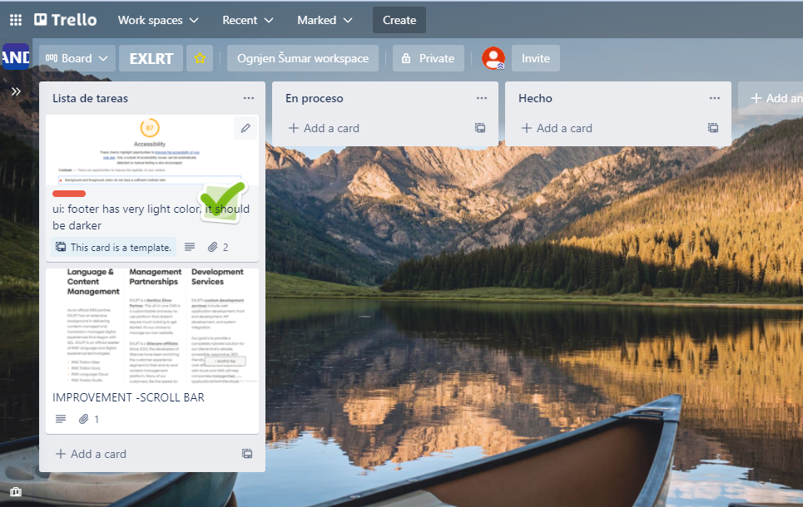

Image 1: used „Trello“ for finding improvements

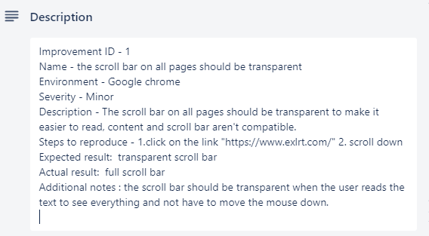

Image 2: Description for improvement

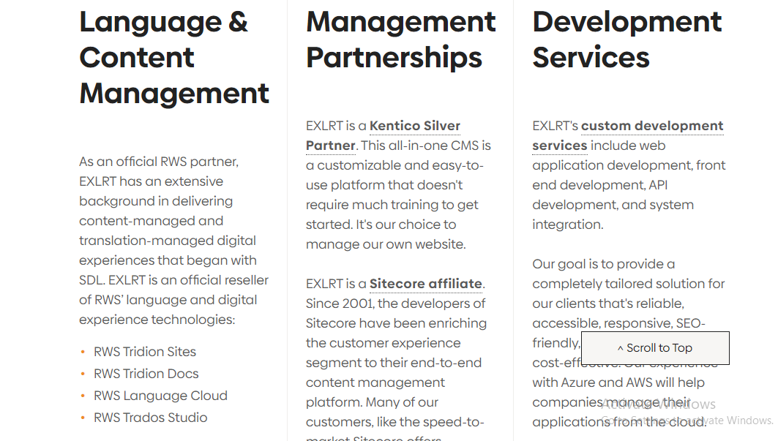

Image 3: content for improvement